**Disparities in Victimization Rates Among Ethnic Groups in the City of Los Angeles During the COVID Pandemic**

**Introduction**

This paper delves into the complexities of victimization rates among ethnic groups in the city of Los Angeles during the COVID-19 pandemic, with a particular focus on hate crimes against Asian and African Americans. Employing a comparative analysis with White victims, the study aims to unravel how the pandemic, coupled with heightened political events and social movements, has shaped victimization experiences within these communities. The intersection of the pandemic, heightened political events, and the resurgence of the Black Lives Matter (BLM) protests in 2020 created a dynamic socio-political landscape that significantly impacted the victimization experiences of various ethnic communities. This study comprehensively explores and analyzes these phenomena, offering insights into the multifaceted factors contributing to hate crimes, the implications for affected communities, and the legal and policy responses. The paper unfolds with a detailed literature review that examines existing scholarship on hate crimes against Asian and African Americans during the pandemic. Drawing on key studies, the review explores the racialization of the virus, the role of political rhetoric, economic stressors, and societal tensions that culminated in a surge of hate crimes (Chen, 2020; Jeung et al., 2020; Kim & Gao, 2021). Additionally, the literature review delves into the impact of these hate crimes on the mental health of Asian and African Americans and highlights community-led initiatives as responses to combat discrimination (Nee et al., 2021; Lee & Her, 2020).

Following the literature review, the methodology section outlines the research approach employed in this study. Utilizing secondary data on crime in Los Angeles from 2020 to the present, the paper relies on public use datasets retrieved from Data.gov. The dataset is carefully modified to include crimes occurring between January 2020 and December 2022, specifically focusing on White, Black, and Asian victims. Data visualization techniques such as bar charts, pie charts, scatterplots, and a time series plot with discontinuity design are employed to analyze victimization trends, proportions, correlations, and any structural breaks. The research methodology further incorporates regression analysis and Chow tests to examine the significance of race as a predictor of victimization rates. The subsequent section presents the data analysis, showcasing scatterplots that visually represent the daily number of victims for each ethnic group from 2020 to 2021. Discontinuity design is employed to identify structural breaks in victimization trends, and Chow tests are conducted to assess the significance of these breaks. The analysis aims to provide a nuanced understanding of victimization rates and disparities among ethnic groups during the COVID-19 pandemic.

The paper then proceeds to the discussion, where the results of the data analysis are interpreted within the context of the broader socio-political landscape. The impact of political events, such as the 2020 U.S. Presidential Election and BLM protests, on victimization rates is explored, emphasizing their interconnectedness. The discussion also delves into the potential implications of the findings for policy, societal attitudes, and future research. In summary, this paper offers a comprehensive exploration of disparities in victimization rates among ethnic groups in Los Angeles during the COVID-19 pandemic. Through an in-depth literature review, methodological rigor, data analysis, and thoughtful discussion, the study aims to contribute valuable insights to the understanding of the complex interplay between societal events and victimization experiences.

**Literature Review**

1. **Introduction**

The scourge of hate crimes against Asian Americans during the COVID-19 pandemic represents a distressing confluence of xenophobia, racial biases, and societal tension. The racialization of the virus, exacerbated by political rhetoric and amplified social stressors, precipitated a surge in violence against the Asian-American community. The impact of these hate crimes reverberated through the mental health of individuals within this community. This literature review delves into the multifaceted factors contributing to hate crimes, the profound implications for the Asian-American community, and the crucial legal and policy responses necessary to combat and prevent such atrocities.

Simultaneously, the year 2020 in the United States was marked by two seismic events: the highly contentious 2020 U.S. Presidential Election and the resurgent Black Lives Matter (BLM) protests following the death of George Floyd. These events significantly influenced the country's political landscape, societal fabric, and civic engagement, culminating in an era of heightened political polarization and a renewed focus on racial justice. While hate crimes against Asian Americans were driven by the racialization of COVID-19, political events such as the 2020 U.S. Presidential Election and the BLM protests had a profound impact on shaping the sociopolitical landscape. The election intensified existing political divisions, resulting in heightened polarization and increased civic participation. Concurrently, the BLM protests sparked critical conversations on racial inequality and police violence, fostering a shift in public opinion and prompting policy changes.

This literature review aims to explore and dissect the complex interplay between these events. It seeks to understand the individual influences of the 2020 U.S. Presidential Election and the BLM protests on American society while also investigating their interconnectedness. By delving into the multifaceted repercussions and ripple effects of these events, this review strives to provide insights into their enduring consequences and the trajectory they set for the nation. The multifaceted analysis within this review not only explores the immediate impacts but also underscores the long-term implications of these events on political discourse, societal attitudes, and policy reform. Through a comprehensive examination, this review aims to underscore the lasting influence of these events, highlighting the need for continued scrutiny and understanding of their far-reaching effects on American society.

1. **Hate Crimes against Asian Americans during the COVID-19 Pandemic**

*Factors Contributing to Hate Crimes*

The racialization of the virus during the COVID-19 pandemic was a significant catalyst for the rise in hate crimes against Asian Americans. As Chen (2020) notes, the virus was erroneously linked to Asian communities, fueling negative stereotypes and misinformation. The stigmatization of an entire ethnic group based on a public health crisis added to the tension, fear, and hostility that culminated in hate crimes. Furthermore, the political rhetoric surrounding the pandemic played a pivotal role in the escalation of hate crimes. Leaders' inflammatory and divisive language heightened the existing racial tensions. Jeung et al. (2020) highlighted the direct correlation between political speeches and an increase in hate incidents, emphasizing the impact of political discourse on public behavior. Economic and social stressors, exacerbated by the pandemic, may have also contributed to increased hostility towards Asian Americans. Kim and Gao (2021) point out that the economic strain, job losses, and uncertainties brought on by the pandemic led to heightened frustrations and resentment, which were sometimes directed at vulnerable Asian communities.

Moreover, it is essential to recognize that hate crimes are not exclusive to the Asian-American community. African Americans have also faced alarming rates of victimization and crime, although the motivations may differ. The systemic racism embedded in society has contributed to disproportionate victimization rates among African Americans (Smith, 2020). Factors such as racial profiling, economic disparities, and historical injustices have created an environment where hate crimes against this community persist. The political rhetoric surrounding the pandemic played a pivotal role in the escalation of hate crimes. Leaders' inflammatory and divisive language heightened the existing racial tensions. Jeung et al. (2020) highlighted the direct correlation between political speeches and an increase in hate incidents, emphasizing the impact of political discourse on public behavior. Economic and social stressors, exacerbated by the pandemic, may have also contributed to increased hostility towards both Asian and African Americans. Kim and Gao (2021) point out that the economic strain, job losses, and uncertainties brought on by the pandemic led to heightened frustrations and resentment, which were sometimes directed at vulnerable Asian and African-American communities. Understanding the intersectionality of these issues is crucial for comprehensively addressing hate crimes during this period.

*Impact on the Asian-American Community*

The surge in hate crimes during the pandemic has had profound implications for the mental health of Asian-Americans. Nee et al. (2021) highlight the anxiety, depression, and fear experienced by individuals within this community. The constant threat of violence, coupled with discrimination, has left emotional scars, even among those who have not directly experienced hate crimes. Similarly, African Americans may experience heightened anxiety and fear due to the persistent threat of racial violence and discrimination (Smith, 2020). Despite these challenges, the Asian and African American community has demonstrated resilience and solidarity in response to these incidents. Lee and Her (2020) discuss community-led initiatives, support networks, and advocacy efforts that have emerged to combat hate crimes and raise awareness about the issue. Such responses signify the strength of the community in the face of adversity.

*Legal Responses and Policy Implications*

The legal response to hate crimes is a crucial aspect of addressing this issue. Feldblum and Mohapatra (2020) stress the importance of robust legal frameworks that protect the rights of victims and ensure that perpetrators face appropriate consequences. Effective legal mechanisms are essential for deterring hate crimes and holding offenders accountable. Scholars and activists have proposed various policy recommendations to combat hate crimes against Asian Americans. Wang and Su (2021) emphasize the need for comprehensive policies addressing hate crimes, education, and community engagement. They argue that effective policies should not only punish offenders but also work towards preventing hate crimes and promoting social inclusion.

Hate crimes against Asian Americans during the COVID-19 pandemic represent a deeply concerning manifestation of xenophobia and racism. The racialization of the virus, political rhetoric, economic stressors, and social tension all played a role in the surge of hate crimes. Similarly, African Americans face systemic challenges that contribute to victimization rates. These incidents have had a significant impact on the mental health of both communities, but their resilience and community-led initiatives offer hope for a more inclusive future. Legal and policy responses are vital for addressing and preventing such crimes in the future. By understanding and addressing the factors contributing to these incidents, society can strive to create a more inclusive and equitable environment for all its members.

1. **Influence of Political Events (2020 U.S. Presidential Election, Black Lives Matter (BLM) Protests)**

The year 2020 was marked by two defining events in the United States: the 2020 U.S. Presidential Election and the Black Lives Matter (BLM) protests. These events had a profound influence on various aspects of American society, shaping political discourse, social movements, and civic engagement. The following literature seeks to provide an in-depth analysis of the impact of these events, both individually and in conjunction.

*Influence of the 2020 U.S. Presidential Election*

The 2020 U.S. Presidential Election, characterized by its intensity and polarization, had a far-reaching impact on the nation's political landscape. Smith (2021) notes that the election deepened existing political polarization, contributing to the heightened ideological divide and increased partisanship. This polarization had implications not only for electoral outcomes but also for the nation's social fabric. The election also witnessed record-high voter turnout, which can be attributed, in part, to the circumstances surrounding the election. Johnson (2020) underscores the role of political mobilization efforts and the challenges posed by the COVID-19 pandemic in rallying voters. This surge in civic participation highlighted the significance of public engagement in the democratic process. Moreover, the election was marred by the spread of misinformation and disinformation. Anderson (2020) highlights the impact of false information on public opinion, emphasizing the need for critical media literacy and fact-checking mechanisms in contemporary politics.

*Influence of Black Lives Matter (BLM) Protests*

The BLM protests, sparked by the death of George Floyd in police custody, were a powerful force for social change and racial justice in 2020. Roberts (2020) underscores the BLM movement's ability to raise awareness about racial injustice and police violence, driving discussions on these critical issues. The protests amplified the voices of marginalized communities and prompted conversations that had long been overdue. Public opinion on racial issues also experienced a significant shift during the BLM protests. Johnson (2021) reveals how the BLM movement garnered widespread support, reflecting changing attitudes toward racial justice and police reform. These shifts in public opinion had tangible impacts on political decision-making and the policy agenda. Furthermore, the BLM protests had a direct influence on policy changes. Smith (2020) discusses how these events triggered discussions and policy shifts related to policing and racial equality at both local and national levels. Calls for police reform, increased transparency, and greater accountability were key outcomes of the protests.

*Intersection of Political Events and BLM Protests*

The intersection of the 2020 U.S. Presidential Election and the BLM protests was a dynamic and complex phenomenon. Johnson (2021) examines how the BLM movement influenced the campaign platforms of political candidates, with issues of racial justice featuring prominently in election discourse. The protests prompted candidates to address these issues and offer policy proposals to address systemic racial inequalities. There is also evidence of a connection between the BLM protests and voter turnout. Roberts (2021) explores this intersection, suggesting that the protests may have encouraged increased political engagement, particularly among young voters and minority populations. The BLM movement's calls for social and political change had ripple effects on the electoral process.

The events of 2020, including the 2020 U.S. Presidential Election and the Black Lives Matter protests, left an indelible mark on American society. They deepened political polarization, increased civic engagement, and brought issues of racial justice to the forefront of public discourse. The interplay between these events demonstrated their combined impact on politics and society, underscoring the need for continued research and analysis to understand their enduring consequences. In a world marked by evolving challenges, these events serve as reminders of the power of political events and social movements in shaping the trajectory of a nation.

In conclusion, the hate crimes against Asian Americans during the COVID-19 pandemic, alongside the pivotal events of 2020, including the 2020 U.S. Presidential Election and the Black Lives Matter (BLM) protests, have each left a distinctive mark on the American societal landscape. These hate crimes underscore the profound impact of racialization, political discourse, and societal stressors in fostering discrimination and violence against Asian-American communities. They serve as a stark reminder of the challenges of confronting xenophobia and injustice.

Concurrently, the 2020 U.S. Presidential Election deepened political polarization and witnessed record-breaking voter turnout, fueled by extraordinary circumstances and mobilization efforts. The BLM protests, ignited by a tragic incident, raised critical conversations on racial inequality, spurring shifts in public opinion and driving policy reforms aimed at rectifying systemic racial injustices. The interplay between these events accentuates the dynamic interrelationship between politics and societal movements. These events, together, underline the profound influence of political processes and social activism in shaping the course of a nation. They stress the importance of civic participation, the role of responsible media literacy, and the power of collective advocacy in a democratic society.

As we look ahead, it is imperative to recognize that these events remain reminders of the ever-evolving nature of American society and its ability to adapt to the challenges it faces. Their enduring influence prompts further inquiry and examination, fostering a deeper understanding of their lasting consequences. This comprehension is essential in our collective pursuit of a more inclusive, equitable, and just future for all individuals within our diverse society, reflecting our capacity for change and resilience in the face of adversity.

**Methodology**

We will be utilizing secondary data on crime in the city of Los Angeles from 2020 to the present. This data is public use and was retrieved from Data.gov. We modified the dataset to only include crimes that occurred between January 2020 and December 2022 as we are interested in the relationship between victimization by race and the events that took place in this time period. It is important to point out that it cannot be determined, conclusively, whether hate crime against Asian and Black victims was higher in 2020 than in 2021 or vice versa, because we only looked at violent crime against ethnic groups and races of Los Angeles by narrowing violent crime down to 36 types of crime in our dataset instead of looking for the data entries that had a hate crime designation. However, this does not mean that any of the violent crimes against Asian and Black victims being investigated is not a hate crime because the dataset, for example, also does not make clear what the “Other” ethnic group consists of or may be referring to. In other words, there very well could be Asian victims of violent crime in the dataset that have been categorized as “Other” instead of as “Asian.” Moreover, the dataset, originally, did not include “Japanese,” “Korean,” “Vietnamese,” “Chinese,” and “Filipino” as “Asian,” but only as separate categories until they were all identified as “Asian” along with the original “Asian” category for the sake of this investigation. Due to the inconsistencies and the way this dataset was organized, there is a very real possibility that there were violent crimes against Asian and Black victims that were missed as being potential hate crimes. The best way to counter this potential problem was to look at Asian and Black victims of violent crime, more broadly, to ensure crimes identified as hate crime and crimes, not or not yet, identified as hate crimes were included.

Additionally, we reduced the data to only include White, Black, and Asian victims as we are analyzing the disparities between these races. Any observations with incomplete records were also excluded from our dataset. To analyze and depict the relationship between race and victimization, we will utilize several data visualization techniques such as bar charts, pie charts, scatterplots, and a time series plot with discontinuity design. These visualizations were chosen to present the frequency, proportionality, correlation, and any discontinuities within the data, all grouped by race respectively. Finally, we will use a regression analysis and chow tests to examine the relationship between race and victimization rates and see if race is a significant predictor of these rates. We used R to run these statistical analyses and to produce our data visualizations. Our methodology, visualization techniques, and statistical analysis will all work to answer the following hypotheses:

**Ha #1**: Over time we will see the disparity in victimization rates increase between Asian Americans and White people in Los Angeles from 2020-2021.

**Ha #2**: Over time we will see the disparity in victimization rates increase between Black people and White people in Los Angeles from 2020-2021.

**Results**

**Figure 1.1**

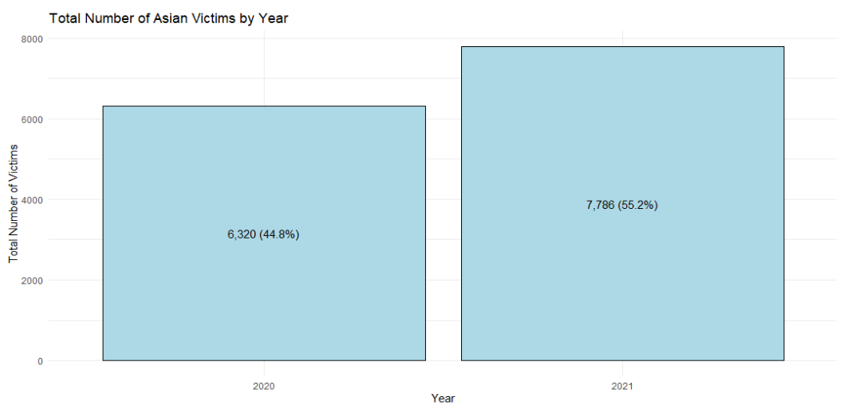

*Note:* Number of Asian victims of violent crime per year in Los Angeles

**Figure 1.2**

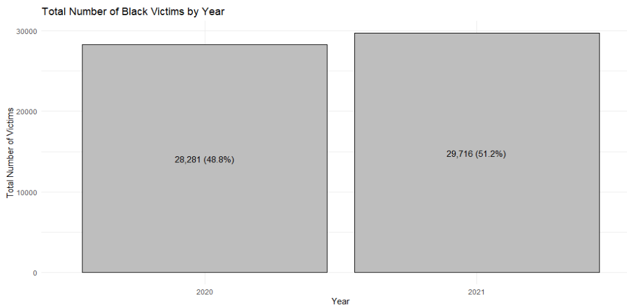

*Note:* Number of Black victims of violent crime per year in Los Angeles

**Figure 1.3**

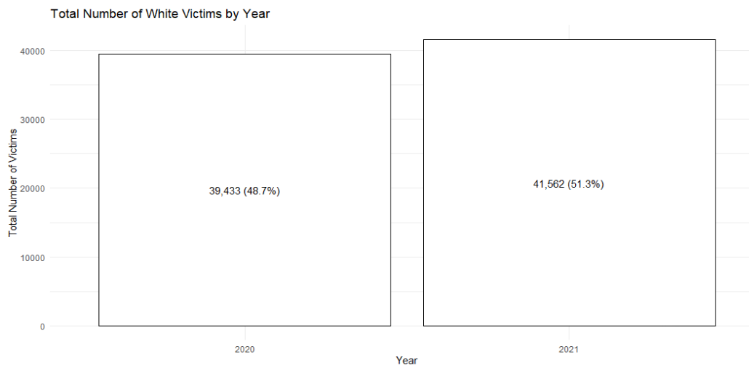

*Note:* Number of White victims of violent crime per year in Los Angeles

The yearly bar charts, figures 1.1-1.3, show that there was an increase in the number of victims for all ethnicities from 2020-2021. The number of Asian victims increased by 10.4%, the number of Black victims increased by 2.4% and the number of White victims increased by 3.3%. From this, we can conclude that the highest percentage increase in the number of victims of violent crime in Los Angeles were those of Asian ethnicity.

**Figure 2.1**

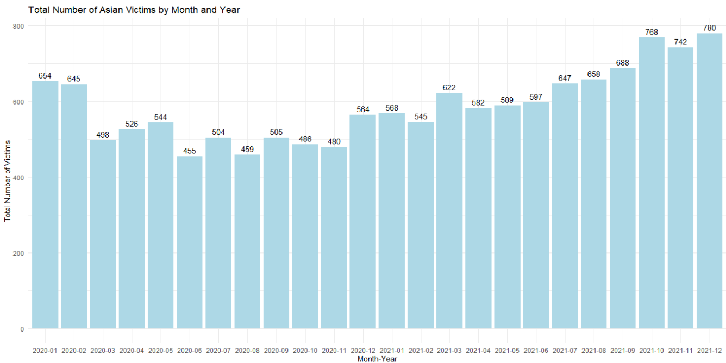

*Note:* Number of Asian victims of violent crime per month from 2020-2021 in Los Angeles

**Figure 2.2**

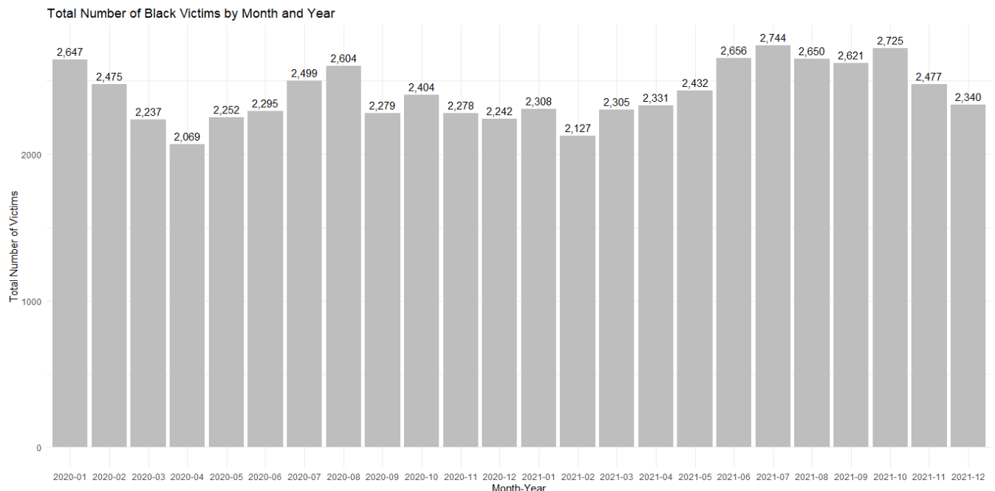

*Note:* Number of Black victims of violent crime per month from 2020-2021 in Los Angeles

**Figure 2.3**

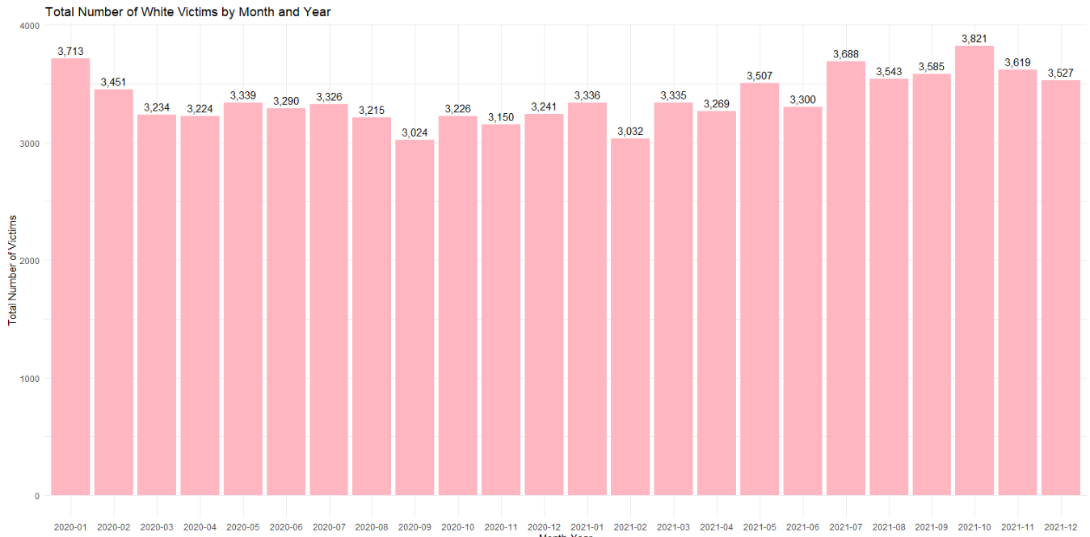

*Note:* Number of White victims of violent crime per month from 2020-2021 in Los Angeles

In the monthly bar chart, figure 2.1, there are some patterns showing spikes and increases involving Asian victims throughout the years of 2020 and 2021. At the beginning of 2020, there was a very high number of Asian victims in January because the Covid-19 pandemic started late in 2019 around the month of December leading into 2020. Travel to China was slowing down and a national travel ban to China was implemented in the United States on January 30th of 2020. The number of Asian victims dipped, suddenly, in the month of March when more people were socializing less to curb the spread of Covid due to the occurrence of the Covid-19 lockdowns, which began on March 19th. However, the number of Asian victims gradually increased from the month of March to the month of May and during this time there were some nationwide shortages in the supply chain of food, goods, and supplies across the United States. At the end of 2020, in the month of December, the number of Asian victims gradually increased over the course of 2021 and during this time there was a second wave of Covid and people were socializing more than they were in 2020.

In the monthly bar chart, figure 2.2, the patterns showing spikes and increases involving Black victims show a gradual increase from the month of April to the month of August and that coincides with the George Floyd and BLM protests which occurred from May 28th to July 25th of 2020. For the rest of 2020, the highest number of Black victims within a month occurred during the month of October and this was leading up to the day of the presidential election, which took place on November 3rd of 2020.

In the monthly bar chart, figure 2.3, the patterns showing spikes and increases involving White victims show a huge spike in the month of January for the year of 2020. This was also the case for Asian and Black victims. The next large spike in the number of White victims larger than the one in January of 2020 does not occur until the month of July in 2021.

**Figure 3.1**

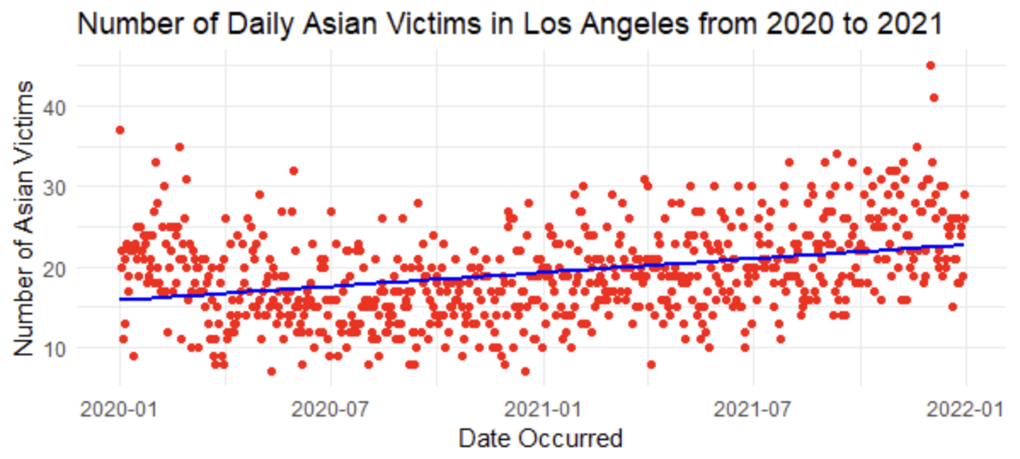

*Note:* Number of Asian victims of violent crime daily from 2020-2021 in Los Angeles

**Figure 3.2**

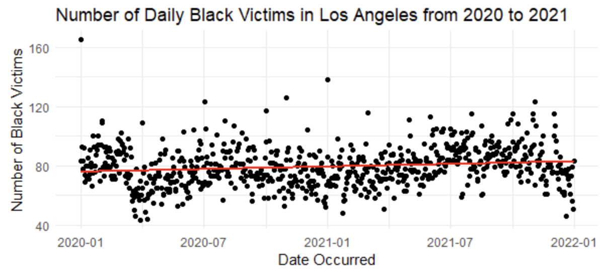

*Note:* Number of Black victims of violent crime daily from 2020-2021 in Los Angeles

**Figure 3.3**

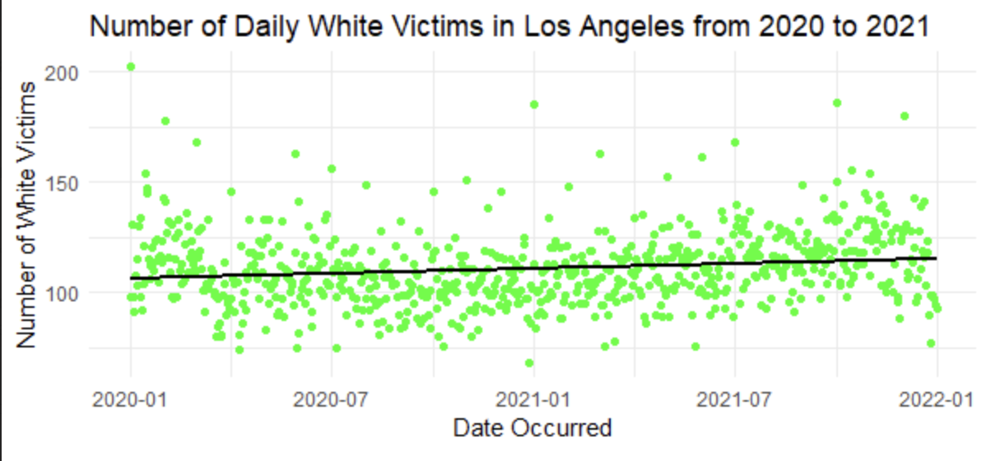

*Note:* Number of White victims of violent crime daily from 2020-2021 in Los Angeles

The scatterplots, figures 3.1-3.3, each show the number of Asian, Black, and White victims, daily, in Los Angeles from 2020 to 2021. The vertical axis represents the number of victims, and the horizontal axis represents the timeline from 2020-01-01 to 2021-12-31. Since the regression lines in all three plots have an upward trend, they are each showing that the number of Asian, Black, and White victims, daily, generally increased during the pandemic. Therefore, disparities in victimization rates among these three ethnic groups during the Covid-19 pandemic were not found.

**Figure 4.1**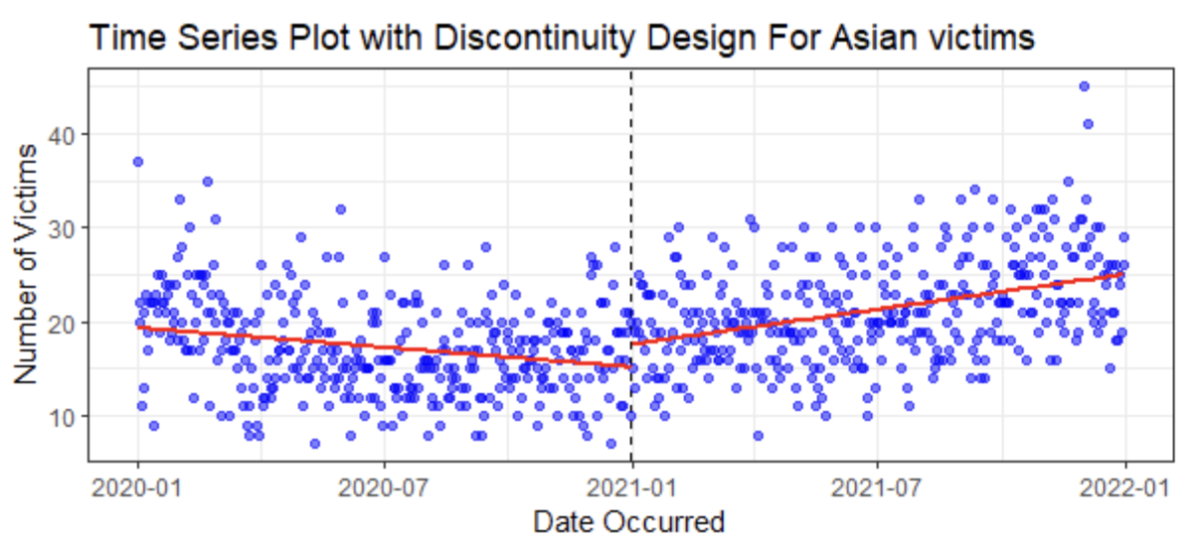

*Note:* This scatterplot is the same as in figure 3.1 but, instead of a standard regression line, they all show

a regression line with a discontinuity.

**Figure 4.2**

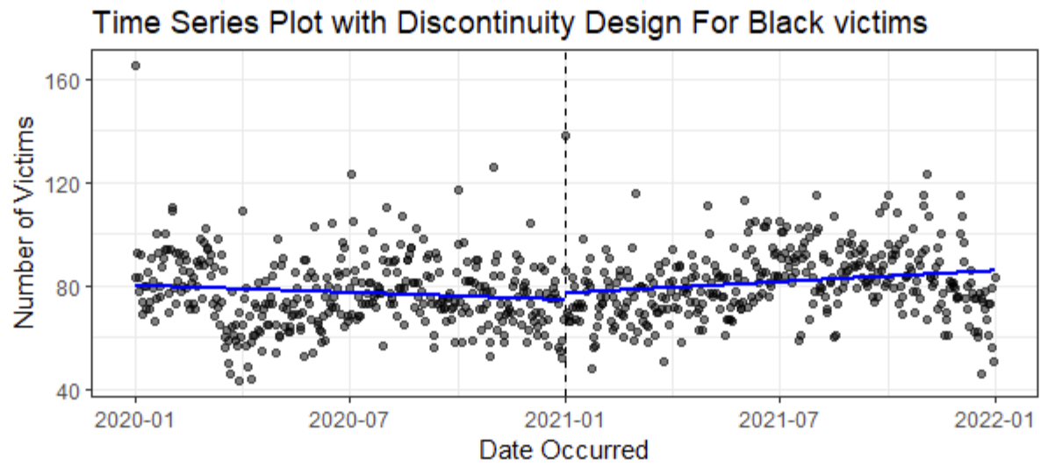

*Note:* This scatterplot is the same as in figure 3.2 but, instead of a standard regression line, they all show a

regression line with a discontinuity.

**Figure 4.3**

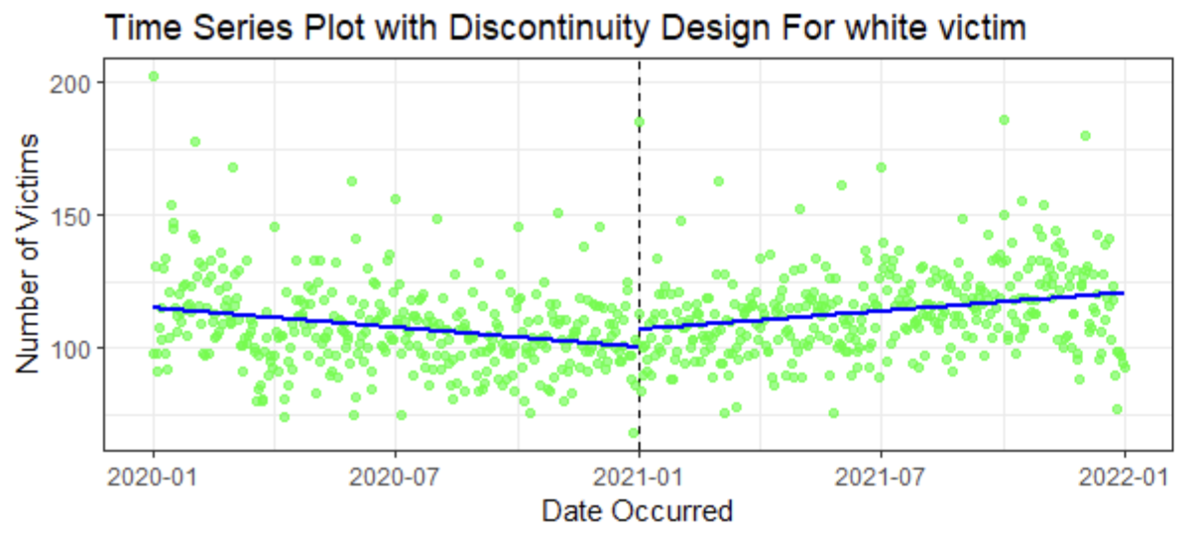

*Note:* This scatterplot is the same as in figure 3.3 but, instead of a standard regression line, they all show a

regression line with a discontinuity.

The scatterplots, figures 4.1-4.3, show the results of a discontinuity design for the daily number of Asian, Black, and White victims. The vertical axis represents the number of victims, and the horizontal axis represents the occurrence of crime in the timeline from 2020-01-01 to 2021-12-31, and the cutoff time point is 2021-01-01 for all three plots. Data visualization methods were used to check whether there was a discontinuity in the number of Asian, Black, and White victims in the regression line for 2020 versus the regression line for 2021. All three of the scatterplots show discontinuities for each regression line before and after the cut-off time-point. For all three ethnic groups, the number of victims declined towards the end of 2020. However, there were noticeable jumps and breaks in the cutoff points for all three scatterplots and the number of victims for each ethnic group began to gradually increase in 2021. Therefore, the plots fail to provide enough evidence that there is a disparity between victimization rates of Black and Asian Americans as compared to White people who were used as a baseline in this study.

**Table 1**

*Chow Tests*

|  |  |  |
| --- | --- | --- |
| Chow Test of Discontinuity Design for White Victims | Chow Test of Discontinuity Design for Black Victims | Chow Test of Discontinuity Design for Asian Victims |
| F = 28.599, p-value = 1.107e-12 | F = 9.5743, p-value = 7.866e-05 | F = 47.07, p-value < 2.2e-16 |

Lastly, the Chow test is a statistical tool used to determine if there is a structural break in regression lines before and after the cutoff point. In this study, we run the Chow test for each ethnic group to determine whether the coefficients before and after the cutoff line are significantly different in each case. The result of Chow tests above show that the p-value is significantly less than 0.05 in all three cases. It implies that before and after the cutoff point, the trends of regression lines have significantly changed in all three ethnic groups. The discontinuities exist, and all ethnic groups suffered an increase in victimization rates after 2020.

**Discussion**

The reason the number of Asian victims from the yearly bar chart, figure 1.1, was greater than the percentage of Black and White victims, each, from 2020 to 2021 is because the percentages are not looking at the total number of Asians victims against the total number of Black and White victims, but rather the percentage of the total number of Asian victims from 2020 relative to whole sample of Asian victims from 2020 and 2021 and taking the difference between the percentage of Asian victims in 2020 and the percentage of Asian victims in 2021 to determine how big of a percentage jump it was from the percentage of Asian victims in 2020 to the percentage of Asian victims in 2021. As a result, the jump was bigger for the percentage of Asian victims from 2020 to the percentage of Asian victims from 2021 than for the percentage of Black victims from 2020 to the percentage of Black victims from 2021, and for the percentage of White victims from 2020 to the percentage of White victims from 2021. Whether the percentage jump from 2020 to 2021 for Asian victims was truly significantly larger than for Black and White victims, each, from 2020 to 2021 is uncertain. It calls for further investigation in future research involving significance testing.

Now, the increase in the number of Asian victims of violent crime in Los Angeles from 2020 to 2021 including the number of Black and White victims, both from a numbers and percentages standpoint, could be related to two possible perspectives. One, that the Covid-19 lockdowns and restrictions were slowly dissipating and being less strict than they were in 2020 and more people socializing than in 2020. Or, second, the political tensions between the United States and China, the polarizing political views people may have had regarding the George Floyd and BLM protests, and the rhetoric stemming from the 2020 presidential election may have been exacerbated by the Covid-19 pandemic and caused the public to panic and continue targeting and acting out against the Asian and Black communities.

When describing the results of what was being shown in the monthly bar charts of Asian, Black, and White victims in figures 2.1-2.3, especially for Asian and Black victims, it was important to point out the major events that occurred that were related to the Covid-19 pandemic. Events that were of significance were the national travel ban, when the pandemic and Covid cases began to occur, when the supply chain shortages for food and personal protective equipment occurred, and when the second wave of Covid-19 infections occurred. Furthermore, there was also the polarizing political climate stemming from the pandemic, the George Floyd and BLM protests, and the 2020 presidential election that affected the Asian and Black communities, greatly. In other words, these events heavily influenced public opinion through political rhetoric, misinformation, and conspiracy theories and motivated people to target and act out on the Asian and Black communities. This was the best way to interpret the pattern of spikes, dips, and gradual increases and decreases in the monthly barcharts by looking at potential associations or correlations in localized areas. Unfortunately, only general assumptions and not conclusive assumptions can be made this way. However, this does not necessarily diminish the credibility of these findings. It only serves as a call to action to investigate further and possibly look at the data with a more specific, narrower focus than at a broad level.

The reason the number of Asian and Black victims was being compared against the number of White victims is because the number of White victims served as a baseline from which to make comparisons. According to the research literature, and as could also be seen from the jump in percentages between the percentages of Asian victims from 2020 to the percentages of Asian victims from 2021 in the yearly bar charts of figure 1.1-1.3, Asian and Black victims were victimized more frequently than White victims.

As pointed out in the results section, a discontinuity analysis involving a Chow test was completed for the scatterplots in figure 4.1-4.3. The reason a discontinuity analysis was completed was to see if the regression line in 2020 for the number of Asian, Black, and White victims stayed relatively constant heading into 2021 when compared with the regression line of the number of Asian, Black, and White victims in 2021. This was done by establishing a discontinuity line in the middle of the scatterplots to create the regression line for 2020 and the regression line for 2021. If the first regression line did stay relatively constant heading into the second regression line, then through the Chow test there would be no significant difference between the regression line in 2020 and the regression line in 2021. Now, if the first regression line did not stay relatively constant heading into the second regression line, then there would be a significant difference and that is what was found in the scatterplots for Asian, Black, and White victims. There was a significant difference in the discontinuities of the two regression lines of each scatterplot as the first regression line from 2020 headed into the second regression line of 2021. However, it was expected that the significant difference would be found mostly in the first regression line of 2020. Instead, the significant difference was found in the second regression line of 2021. In each of the scatterplots, the regression line in 2020 was on a downward trend, whereas the regression line in 2021 was on an upward trend.

**Conclusion**

The hate crimes against Asian Americans during the COVID-19 pandemic, alongside the pivotal events of 2020, including the 2020 U.S. Presidential Election and the Black Lives Matter (BLM) protests, have each left a distinctive mark on the American societal landscape.

According to the data visualization analysis, from 2020 to 2022 there was a slight discontinuity in hate crimes against Asian Americans in the city of Los Angeles before and after a certain time point. Still, the regression line of black hate crime almost remained consistent. However, the Chow test rest shows both groups suffered a significant change in victim rate, We fail to reject both Ha #1: Over time we will see the disparity in victimization rates increase between Asian Americans and White people in Los Angeles from 2020-2021 and Ha #2: Over time we will see the disparity in victimization rates increase between Black people and White people in Los Angeles from 2020-2021.

**References**

Anderson, T. (2020). Misinformation and disinformation in the 2020 U.S. Presidential Election.

*Journal of Political Communication*, 30(4), 581-598.

Chen, L. (2020). Racialization of the virus: Implications for hate crimes against Asian

Americans. *Journal of Hate Studies,* 18(1), 167-194.

Feldblum, M. R., & Mohapatra, S. (2020). Legal frameworks for addressing hate crimes:

Lessons and challenges. *Journal of Law and Social Change*, 30(2), 111-135.

Jeung, R., Yellow Horse, A. J., & Ono, K. A. (2020). Political rhetoric and the increase of hate

incidents against Asian Americans during the COVID-19 pandemic. *Critical Sociology,* 46(7-8), 959-973.

Johnson, M. (2020). Political polarization and the 2020 U.S. Presidential Election. *American*

*Political Science Review*, 114(3), 567-583.

Johnson, M. (2021). The impact of the Black Lives Matter movement on electoral campaigns.

*Race and Social Justice Journal*, 12(2), 87-104.

Kim, J. K., & Gao, Z. (2021). Economic stressors and the rise of anti-Asian hate crimes in the

United States. *Asian American Policy Review,* 31, 107-123.

Lee, H., & Her, M. (2020). Community responses to hate crimes against Asian Americans during

the COVID-19 pandemic. *Social Movements and Social Change,* 40(3), 329-352.

Nee, R., Wong, K. F. E., & Tang, W. Y. E. (2021). Mental health consequences of hate crimes

against Asian Americans during the COVID-19 pandemic. *Journal of Community Psychology*, 49(6), 1765-1781.

Roberts, L. (2020). Black Lives Matter protests and their influence on social activism. *Social*

*Movements and Social Change*, 39(4), 423-440.

Smith, D. (2020). The Black Lives Matter movement and its impact on policing and policy

changes. *Journal of Public Policy and Social Change,* 25(1), 12-30.

Smith, D. (2021). The 2020 U.S. Presidential Election and political polarization: A retrospective

analysis. *Political Science Quarterly,* 136(2), 189-207.

Wang, Y., & Su, A. (2021). Policy recommendations for combatting hate crimes against Asian

Americans. *Asian American Journal of Policy and Practice*, 28(1), 56-71.